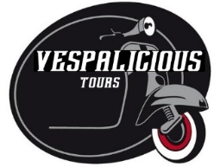

PILLION RIDER RELEASE OF LIABILTY FORM

This agreement releases VESPALICIOUS and DUSKY LEAF ADVENTURES (M) SDN BHD from all liability relating to injuries, fatalities and loss of belongings that may occur during the Vespa tours.
By signing this agreement, I agree to hold VESPALICIOUS and DUSKY LEAF ADVENTURES (M) SDN BHD entirely free from any liability, including financial responsibility for injuries incurred, regardless of whether injuries are caused by negligence.
I also acknowledge the risks involved in this Vespa tour. These include but are not limited to collision with pedestrians, vehicles, other riders and fixed or moving objects; the dangers arising from surface hazards, equipment failure, inadequate safety equipment, etc. I swear that I am participating voluntarily, and that all risks have been made clear to me. Additionally, I do not have any conditions that will increase my likelihood of experiencing injuries while engaging in this activity.
By signing below, I forfeit all right to bring a suit against VESPALICIOUS and DUSKY LEAF ADVENTURES (M) SDN BHD for any reason. I will also make every effort to obey safety precautions as listed in writing and as explained to me verbally. I will ask for clarification when needed.

I / We, ___________________________________________________________________, fully understand and agree to the above terms.

Signature : _____________________ Signature : ______________________

Name : _____________________ Name : ______________________

ID / Passport No: ____________________ ID / Passport No: _____________________

Date : _______________________

Updated: Saturday, October 29, 2022

